**AutoGeneralAPI – Application Running Instructions**

1. Download and import the maven project in eclipse
2. Update/build the imported maven project in eclipse

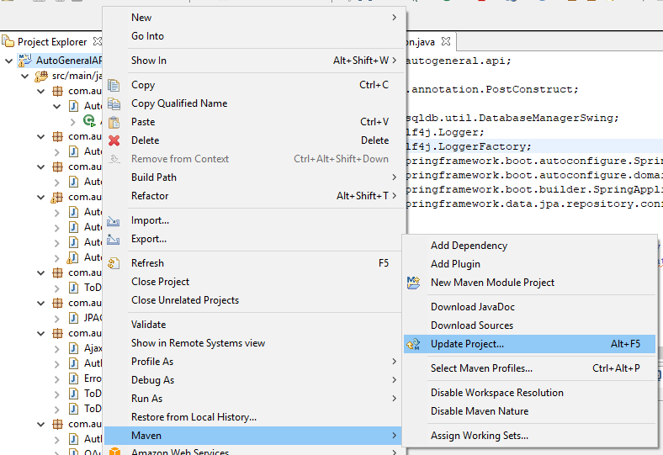

1. Run the application

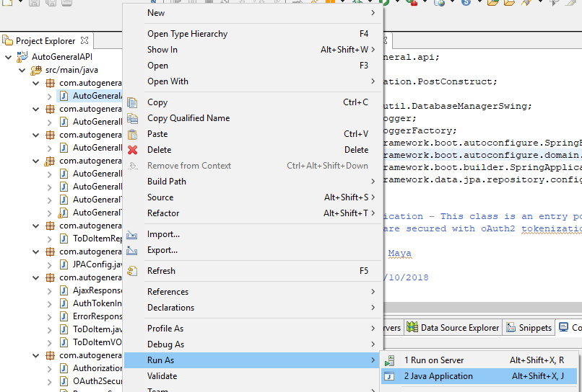



1. For Testing Open Postman

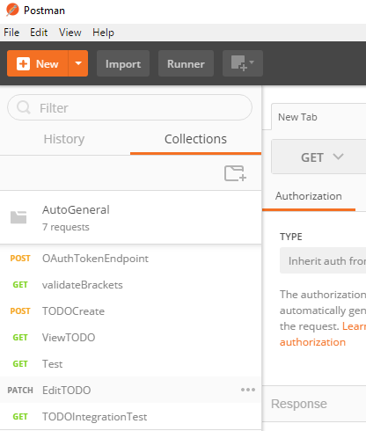

1. **/validateBrackets**

1.1 When the inputString is Valid

Request:

**Method: GET**

**URL :** [**http://localhost:8080/autogeneral/tasks/validateBrackets?inputString=Bindhya(100)**](http://localhost:8080/autogeneral/tasks/validateBrackets?inputString=Bindhya(100))

**Response**:

**{ input: Bindhya(100), isBalanced: true }**

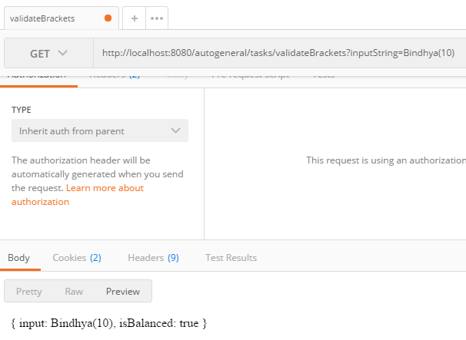

1.2 When inputString is not valid

Request

**Method: GET**

**URL :** [**http://localhost:8080/autogeneral/tasks/validateBrackets?inputString=Bindhya([100]{99)**](http://localhost:8080/autogeneral/tasks/validateBrackets?inputString=Bindhya(%5b100%5d%7b99))

**Response**:

**{ input: Bindhya([100]{99), isBalanced: false }**

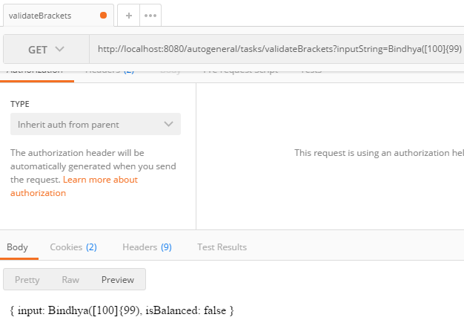

1.3 When inputString is greater than 50 characters

**Request**:

**Method: GET**

**URL:** [**http://localhost:8080/autogeneral/tasks/validateBrackets?inputString=Bindhyaokokokokokokokokokokokokokthththththgygygygygy**](http://localhost:8080/autogeneral/tasks/validateBrackets?inputString=Bindhyaokokokokokokokokokokokokokthththththgygygygygy)

**Response**:

400 Bad Request:

**{"errors":["inputString length must be between 1 and 50"]}**

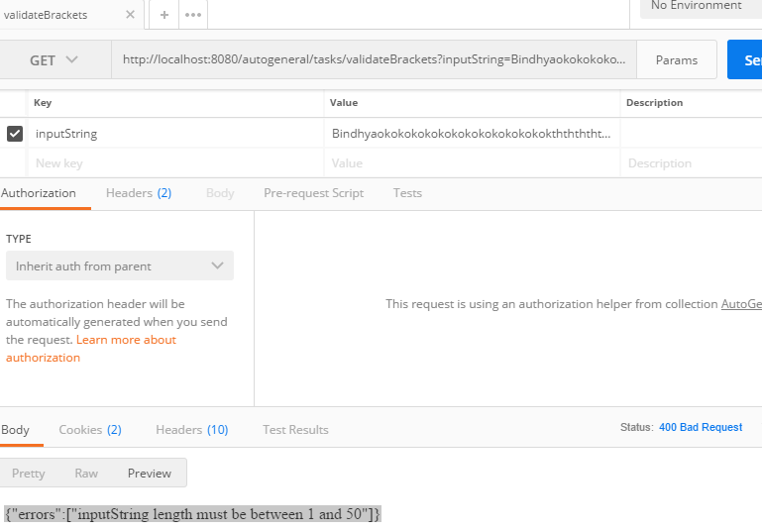

TODO

1. Create a new ToDoItem

Request:

**Method : POST**

**url ;** [**http://localhost:8080/autogeneral/todo**](http://localhost:8080/autogeneral/todo)

**Body: {**

**"id": 1,**

**"text": "Uulwi ifis halahs gag erh'ongg w'ssho",**

**"createdAt": "2017-10-13T01:50:58.735Z",**

**"completed": true**

**}**

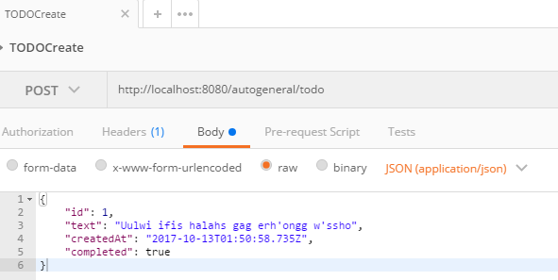

Response

200 OK

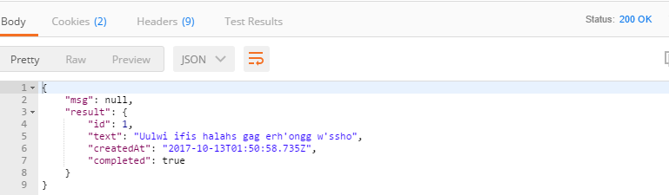

1.1 If new Text has greater than 50 characters then Validation error

**Request**

{

"id": 1,

"text": "Uulwi ifis halahs gag erh'ongg w'sshopopopopopopopopopopopopopop",

"createdAt": "2017-10-13T01:50:58.735Z",

"completed": true

}

**Response**

{

"msg": "text must be between 1 and 50 chars long",

"result": null

}

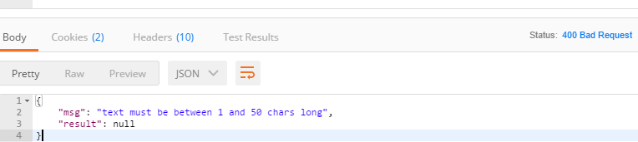

1. Edit TODO

Request

**Method: PATCH**

**url:** [**http://localhost:8080/autogeneral/todo/?id=1**](http://localhost:8080/autogeneral/todo/?id=1)

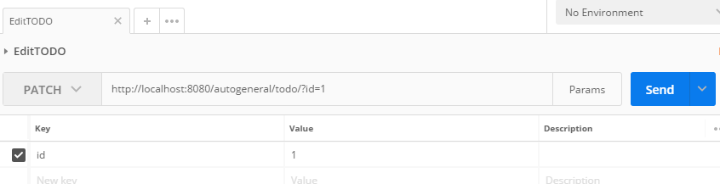

**Response**

200 OK

{

"msg": null,

"result": {

"id": 1,

"text": "This is an edited text",

"createdAt": "2017-10-13T01:50:58.735Z",

"completed": true

}

}

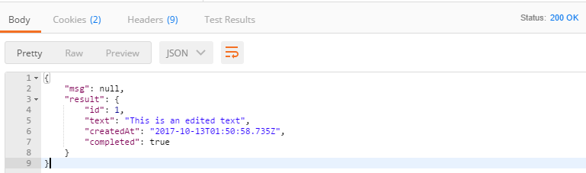

1. View TODO

Request

**Method: GET**

**url** [**http://localhost:8080/autogeneral/todo/?id=1**](http://localhost:8080/autogeneral/todo/?id=1)

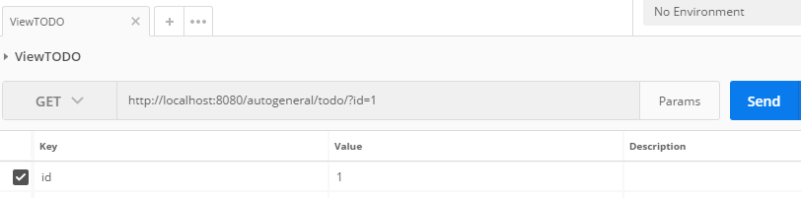

**Response**

200 OK

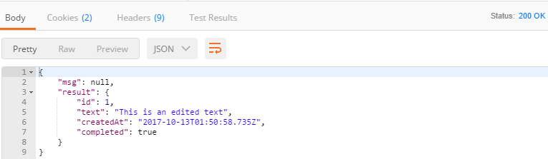

3.1 When ToDoItem is Not found

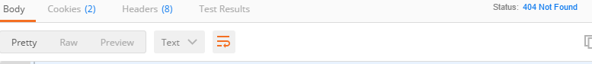

1. IntgerationTest

Request:

**Method: GET**

**Url:** [**http://localhost:8080/autogeneral/integrationTest?apiUrl=http://localhost:8080/autogeneral**](http://localhost:8080/autogeneral/integrationTest?apiUrl=http://localhost:8080/autogeneral)

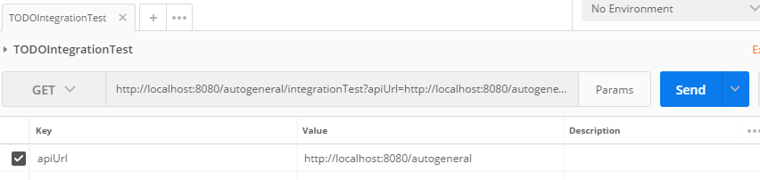

**Response**

